Employee Database
create database emp;
use emp;

CREATE TABLE dept (
deptno decimal(2,0) primary key,
dname varchar(14) default NULL,
loc varchar(13) default NULL);

CREATE TABLE emp (
empno decimal(4,0) primary key,
ename varchar(10) default NULL,
mgr_no decimal(4,0) default NULL,
hiredate date default NULL,
sal decimal(7,2) default NULL,
deptno decimal(2,0) references dept(deptno) on delete cascade on update cascade);

create table incentives (
empno decimal(4,0) references emp(empno) on delete cascade on update cascade,
incentive_date date,
incentive_amount decimal(10,2),
primary key(empno,incentive_date));

Create table project (
pno int primary key,
pname varchar(30) not null,
ploc varchar(30));

Create table assigned_to (
empno decimal(4,0) references emp(empno) on delete cascade on update cascade,
pno int references project(pno) on delete cascade on update cascade,
job_role varchar(30),
primary key(empno,pno));

show tables;
INSERT INTO dept VALUES (10,'ACCOUNTING','MUMBAI');
INSERT INTO dept VALUES (20,'RESEARCH','BENGALURU');
INSERT INTO dept VALUES (30,'SALES','DELHI');
INSERT INTO dept VALUES (40,'OPERATIONS','CHENNAI');
INSERT INTO emp VALUES (7369,'Adarsh',7902,'2012-12-17','80000.00','20');
INSERT INTO emp VALUES (7499,'Shruthi',7698,'2013-02-20','16000.00','30');
INSERT INTO emp VALUES (7521,'Anvitha',7698,'2015-02-22','12500.00','30');
INSERT INTO emp VALUES (7566,'Tanvir',7839,'2008-04-02','29750.00','20');
INSERT INTO emp VALUES (7654,'Ramesh',7698,'2014-09-28','12500.00','30');
INSERT INTO emp VALUES (7698,'Kumar',7839,'2015-05-01','28500.00','30');
INSERT INTO emp VALUES (7782,'CLARK',7839,'2017-06-09','24500.00','10');
INSERT INTO emp VALUES (7788,'SCOTT',7566,'2010-12-09','30000.00','20');
INSERT INTO emp VALUES ('7839','KING',NULL,'2009-11-17','500000.00','10');
INSERT INTO emp VALUES ('7844','TURNER',7698,'2010-09-08','15000.00','30');
INSERT INTO emp VALUES ('7876','ADAMS',7788,'2013-01-12','11000.00','20');
INSERT INTO emp VALUES ('7900','JAMES',7698,'2017-12-03','9500.00','30');
INSERT INTO emp VALUES ('7902','FORD','7566','2010-12-03','30000.00','20');

INSERT INTO incentives VALUES(7499,'2019-02-01',5000.00);
INSERT INTO incentives VALUES(7521,'2019-03-01',2500.00);
INSERT INTO incentives VALUES(7566,'2022-02-01',5070.00);
INSERT INTO incentives VALUES(7654,'2020-02-01',2000.00);
INSERT INTO incentives VALUES(7654,'2022-04-01',879.00);
INSERT INTO incentives VALUES(7521,'2019-02-01',8000.00);
INSERT INTO incentives VALUES(7698,'2019-03-01',500.00);
INSERT INTO incentives VALUES(7698,'2020-03-01',9000.00);
INSERT INTO incentives VALUES(7698,'2022-04-01',4500.00);
INSERT INTO project VALUES(101,'AI Project','BENGALURU');
INSERT INTO project VALUES(102,'IOT','HYDERABAD');
INSERT INTO project VALUES(103,'BLOCKCHAIN','BENGALURU');
INSERT INTO project VALUES(104,'DATA SCIENCE','MYSURU');
INSERT INTO project VALUES(105,'AUTONOMUS SYSTEMS','PUNE');
INSERT INTO assigned_to VALUES(7499,101,'Software Engineer');
INSERT INTO assigned_to VALUES(7521,101,'Software Architect');
INSERT INTO assigned_to VALUES(7566,101,'Project Manager');
INSERT INTO assigned_to VALUES(7654,102,'Sales');
INSERT INTO assigned_to VALUES(7521,102,'Software Engineer');
INSERT INTO assigned_to VALUES(7499,102,'Software Engineer');
INSERT INTO assigned_to VALUES(7654,103,'Cyber Security');

INSERT INTO assigned_to VALUES(7698,104,'Software Engineer');
INSERT INTO assigned_to VALUES(7900,105,'Software Engineer');
INSERT INTO assigned_to VALUES(7839,104,'General Manager');

Select * from dept;
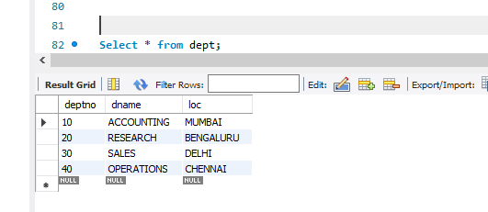

select * from emp;
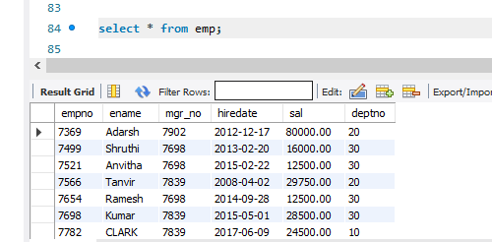

select * from incentives;
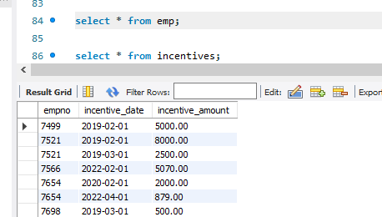

select * from project;
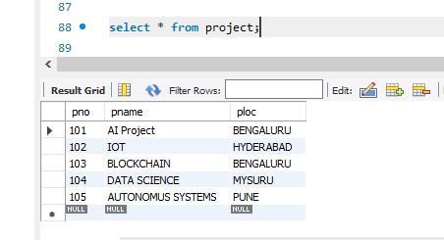
select * from assigned_to;
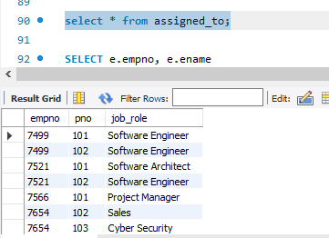

1. Get Employee ID’s of those employees who didn’t receive incentives
SELECT e.empno, e.ename
FROM emp e
LEFT JOIN incentives i
ON e.empno = i.empno
WHERE i.empno IS NULL;
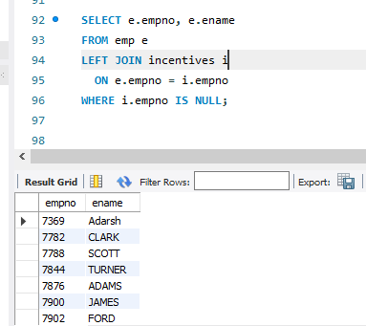

2. List the name of the managers with the most employees
SELECT m.ename, count(*)
FROM emp e,emp m
WHERE e.mgr_no = m.empno
GROUP BY m.ename
HAVING count(*) =(SELECT MAX(mycount)
from (SELECT COUNT(*) mycount
FROM emp
GROUP BY mgr_no) a);
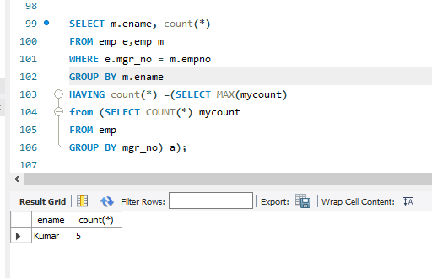
3. Display those managers name whose salary is more than average salary of his
employee?
SELECT *
FROM emp m
WHERE m.empno IN
(SELECT mgr_no
FROM emp)
AND m.sal >
(SELECT avg(e.sal)
FROM emp e
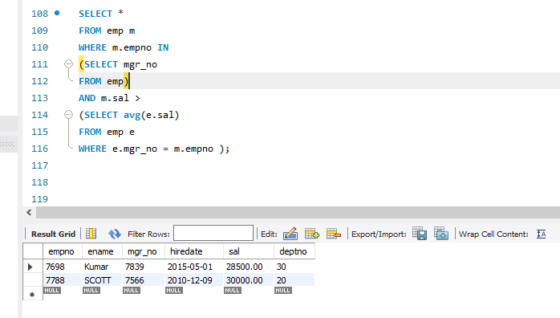
WHERE e.mgr_no = m.empno );

4. SQL Query to find the employee details who got second maximum incentive in
Febrauary 2019.
select *
from emp e,incentives i
where e.empno=i.empno and 2 = ( select count(*)
from incentives j
where i.incentive_amount <= j.incentive_amount );

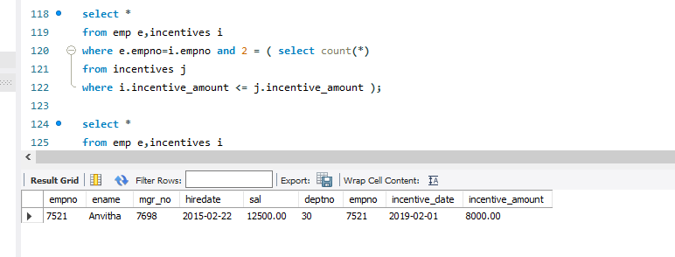

5. Display those employees who are working in the same dept where his manager
is work. ?
SELECT *
FROM EMP E
WHERE E.DEPTNO = (SELECT E1.DEPTNO
FROM EMP E1
WHERE E1.EMPNO=E.MGR_NO);
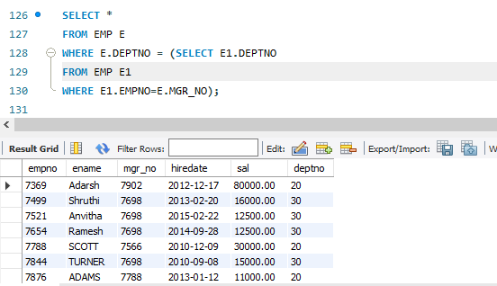

6. Retrieve the employee numbers of all employees who work on project located
in Bengaluru, Hyderabad, or Mysuru
select e.empno
from emp e, assigned_to a, project p
where e.empno=a.empno and a.pno=p.pno and
p.ploc in ('Bengaluru','Hyderabad','Mysuru');
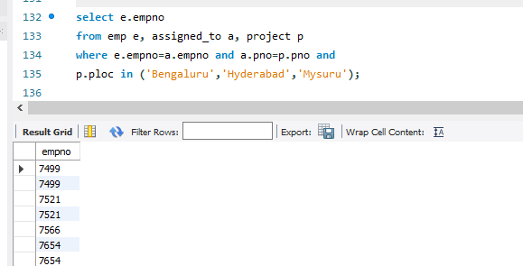
7. Write a SQL query to find those employees whose net pay are higher than or
equal to the salary of any other employee in the company
SELECT DISTINCT e.ename
FROM emp e
LEFT JOIN incentives i ON e.empno = i.empno
GROUP BY e.empno, e.ename, e.deptno, e.sal
HAVING (e.sal + IFNULL(SUM(i.incentive_amount), 0)) >= ANY (
SELECT sal
FROM emp e1
WHERE e.deptno = e1.deptno
);
